**Testing Approach:**

32 test cases are created. These tests covered smoke,regression and can be used also in the uat (user acceptance testing) of the application.The tests are defined per each module for the application.

For the automation tool I have selenium webdriver with java.I have selected 12 test cases to be automated.These test cases covers the regression and smoke testing.

**Framework:**

The framework that I have chosen is hybrid framework.Hybrid framework is a combination between data driven , page object pattern,TestNG Reporting & TestNG Reporter Logs.

**Tests covered and Results:**

12 test are selected that define the scope of smoke and regression.All the positive scenarios were covered and some negative scenarios were selected based on the importance of these tests to the business. The test results are shown in the report that is createded by testNg (Test framework that I have used).

**How to run the automated tests?**

There is more than one way to run the automated tests. If you have eclipse or intellij , then load the project into any of these ide. Then right click on the package that has the tests and select run as TestNg 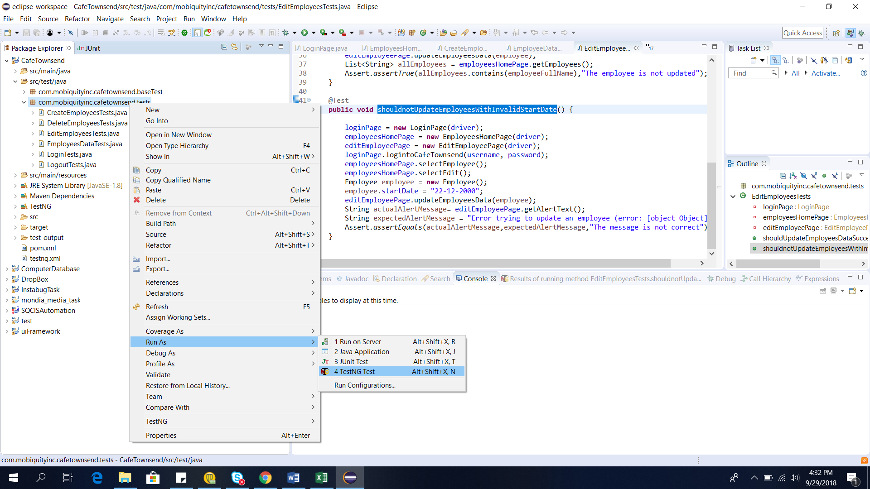

If you want to run the tests without opening the project in eclipse.So you have to download maven from here <https://maven.apache.org/download.cgi>.

Then open the main directory where the pom.xml file exists, open the cmd in this directory and run this command “mvn test”.

The configurations of this application are found in this file “src/main/resources/conf/application.properties”

In this file you can change you can change the browser, username or password and url of the application in case you want to run on different environment.

After the running of the tests is finished a new folder “test-output” will be created. In this file we will find a file “index.html”.If you open this file, you will find a report about the running tests which test case passed and failed and the execution time of each test.